**Chapter 12 Cap Budgeting Cash Flow**

Cash Flows

Incremental – cash flows that change because of the project

Incidental – type of incremental – Example, Ford Focus and CAFE (Corporate Average Fuel Economy)

Cars 27.5 mpg Lt Trucks 20.7 mpg Trucks < 8500 22.5 mpg 2008, 23.1 2009, 23.5 2010

Sunk Costs – Example of Finance students switching to Econ

Depreciation

Why do we depreciate – we’d rather expense. (New tax code?)

Various methods, we cover two.

Straight line: Annual deprec = (cost-salvage)/life

MACRs: Annual deprec = cost X percentage where the percentage dictated by gov’t mandate and life. Base cost stays the same.

|  |  |  |  |  |
| --- | --- | --- | --- | --- |
| Year | 3-year | 5-year | 7-year | 10-year |
| 1 | 0.333 | 0.200 | 0.143 | 0.100 |
| 2 | 0.445 | 0.320 | 0.245 | 0.180 |
| 3 | 0.148 | 0.192 | 0.175 | 0.144 |
| 4 | 0.074 | 0.115 | 0.125 | 0.115 |
| 5 |  | 0.115 | 0.089 | 0.092 |
| 6 |  | 0.058 | 0.089 | 0.074 |
| 7 |  |  | 0.089 | 0.066 |
| 8 |  |  | 0.045 | 0.066 |
| 9 |  |  |  | 0.065 |
| 10 |  |  |  | 0.065 |
| 11 |  |  |  | 0.033 |

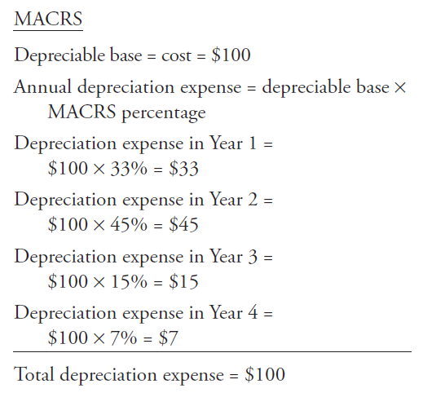

Changes in Working Capital

What is it?

Goes back to incremental on whether to count or not.

Recapture – e.g., %

Tax impacts on Cap Bud cash flows

1. Normal income taxes on EBT for the project
2. Taxes on asset sales. Compare sales price to book value – tax the gains or take the tax shield loss.

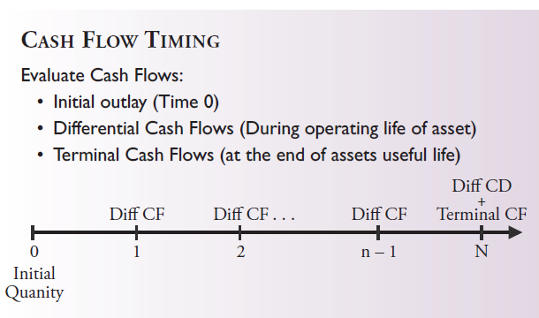

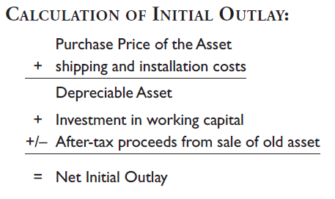

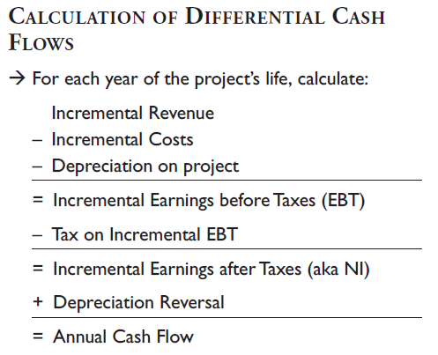

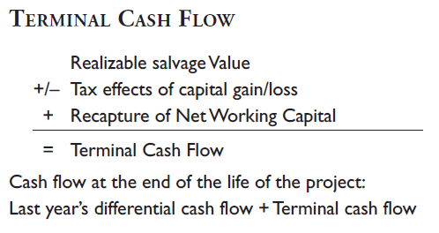

Putting it together

Cap budgeting in 3 steps

Evaluate Cash Flows (this chapter 12)

Assess Project Risk (Chapter 9)

Accept or Reject Project (Chapter 11)

Practice problems.